SIMATS ENGINEERING
ASSESSMENT TOOL 2

COURSE NAME: INTERNET PROGRAMMING
COURSE CODE: CSA43

COURSE OUTCOME COVERED

CO-1: Develop well-structured, standards-compliant web pages using HTML/XHTML and XML, and apply Internet protocols and HTTP communication mechanisms for web content delivery. (L2)

Assessment Tool : Data Interpretation

Weightage: 20%

QUESTIONS: Total Marks: 20

1: HTTP Response Analysis
A web server returns the following HTTP response header:
HTTP/1.1 200 OK
Date: Mon, 01 Apr 2026 10:00:00 GMT
Content-Type: text/html
Content-Length: -150
Connection: keep-alive
Questions:
- Identify any incorrect or invalid fields in the header.
- Analyze the issue with Content-Length and explain its impact.
- Determine whether the status code matches the response correctness.
- Suggest corrections for the identified errors.

2: DOM Structure Analysis
Consider the following DOM tree representation:
<html>
<head>
<title>Test Page</title>
</head>
<body>
<div>
<p>Hello World
</div>
</body>
</html>
Questions:
- Identify missing or improperly closed elements.
- Analyze how the browser will interpret this structure.
- Determine the impact on rendering and layout.
- Suggest corrections to make the DOM valid.

3: GET vs POST in Login System
A login system uses two different methods:
Method | URL Example | Data Visibility | Security Level
GET | /login?user=admin&pass=1234 | Visible in URL | Low
POST | /login | Hidden in body | Moderate
Questions:
- Interpret the differences in data transmission between GET and POST.
- Analyze which method is more suitable for login and why.
- Identify security risks in using GET for authentication.
- Suggest best practices for secure login implementation.

4: HTML Code Inspection
Analyze the following HTML snippet:
<!DOCTYPE html>
<html>
<head>
<title>Sample</title>
</head>
<body>
<h1>Welcome
<p>This is a paragraph
<img src="image.jpg">
</body>
</html>
Questions:
- Identify missing closing tags.
- Analyze issues with the <img> tag.
- Determine how browsers will handle these errors.
- Suggest a corrected version of the code.

5: Browser-Server Communication Flow
The following sequence describes a web request:
- User enters a URL in the browser
- DNS lookup occurs
- HTTP request is sent
- Server processes request
- Response is returned
- Browser renders page
Questions:
- Interpret each step in the communication flow.
- Identify where delays can occur.
- Analyze the role of DNS in the process.
- Suggest optimizations to improve performance.

Code of Conduct:

I _K Goutham (192311169) (Name / Reg No) certify that this submission is my original work and that I have adhered to the guidelines specified for this assessment.
I understand that any violation of academic integrity rules will result in disciplinary action.

Signature of the student:

RUBRICS FOR CALCULATION:

Criteria | Weightage | Level 4 (Exemplary) | Level 3 (Proficient) | Level 2 (Developing) | Level 1 (Beginning)
Understanding of Data | 25% | Accurately interprets all data patterns, trends, and relationships | Interprets data correctly with minor gaps | Partial understanding; misses key trends | Misinterprets or fails to understand data
Analysis | 25% | Provides deep analysis with strong logical reasoning and justification | Provides reasonable analysis with some justification | Basic analysis with weak reasoning | No meaningful analysis provided
Application of Concepts | 20% | Effectively applies relevant concepts/tools to interpret data accurately | Applies concepts with minor errors | Limited application; requires guidance | Unable to apply concepts to data
Conclusion | 20% | Draws clear, meaningful conclusions with strong insights and implications | Provides valid conclusions with moderate insights | Conclusions are vague or weak | No clear or valid conclusions
Clarity | 10% | Presents interpretation clearly using proper structure, visuals, and terminology | Generally clear with minor issues | Lacks clarity or proper structure | Poor presentation and difficult to understand

1. HTTP Response Analysis
1. Identify any incorrect or invalid fields in the header
- Content-Length: -150 → Invalid because Content-Length cannot be negative.
- Other fields are valid:
  - HTTP/1.1 200 OK
  - Date
  - Content-Type: text/html
  - Connection: keep-alive
2. Analyze the issue with Content-Length and explain its impact
- Content-Length specifies the size of the response body in bytes.
- A negative value (-150) is invalid according to HTTP standards.
- Impact:
  - Browser may reject the response.
  - Client may fail to display the page.
  - Connection may be terminated.
  - Data transfer becomes unreliable.
3. Determine whether the status code matches the response correctness
- Status code 200 OK means the request was processed successfully.
- However, the invalid Content-Length makes the response malformed.
- Therefore, the response is not completely correct despite the 200 status.
4. Suggest corrections
HTTP/1.1 200 OK
Date: Mon, 01 Apr 2026 10:00:00 GMT
Content-Type: text/html
Content-Length: 150
Connection: keep-alive
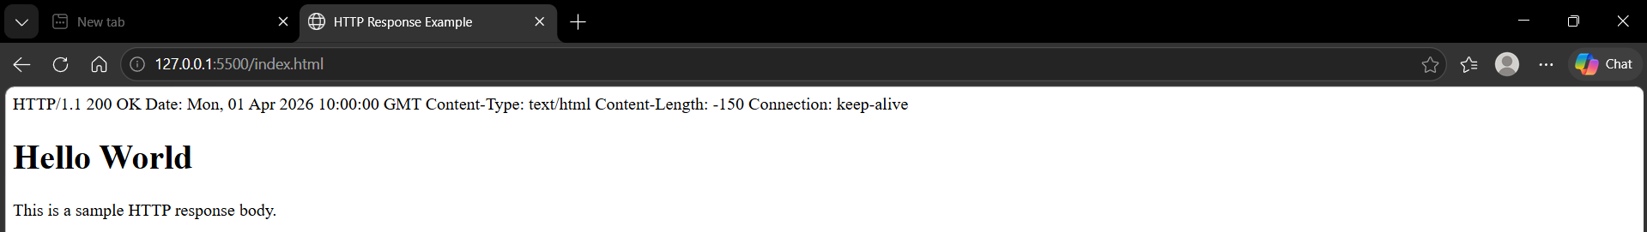

2. DOM Structure Analysis
Given DOM
<html>
<head>
<title>Test Page</title>
</head>
<body>
<div>
<p>Hello World
</div>
</body>
</html>
1. Identify missing or improperly closed elements
- <p> tag is not closed.
- </p> is missing before </div>.
2. Analyze how the browser will interpret this structure
- Modern browsers automatically insert the missing </p> tag.
- DOM becomes approximately:
<div>
<p>Hello World</p>
</div>
3. Determine the impact on rendering and layout
- Most browsers display the page correctly.
- Invalid HTML may cause inconsistent rendering across browsers.
- DOM manipulation with JavaScript may behave unexpectedly.
4. Corrected DOM
<html>
<head>
<title>Test Page</title>
</head>
<body>
<div>
<p>Hello World</p>
</div>
</body>
</html>

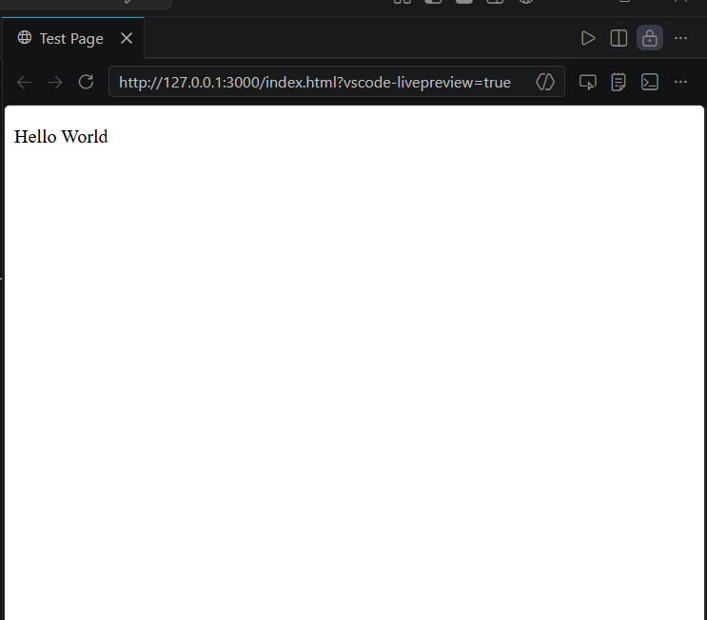

3. GET vs POST in Login System
1. Differences in data transmission
GET | POST
Data sent in URL | Data sent in request body
Visible to everyone | Hidden from URL
Limited data size | Larger data supported
Can be cached | Usually not cached
Used for retrieving data | Used for sending sensitive data

2. Which method is suitable for login?
POST is more suitable because:
- Credentials are not visible in the URL.
- Better privacy.
- Supports HTTPS securely.
- Prevents password exposure in browser history.

3. Security risks of GET
- Username and password appear in URL.
- Stored in browser history.
- Logged by servers.
- Shared accidentally through copied URLs.
- Visible in bookmarks and proxy logs.

4. Best practices for secure login
- Use POST requests.
- Always use HTTPS.
- Hash passwords before storing them.
- Use secure session IDs or tokens.
- Validate user input.
- Enable CSRF protection.
- Implement multi-factor authentication (MFA).

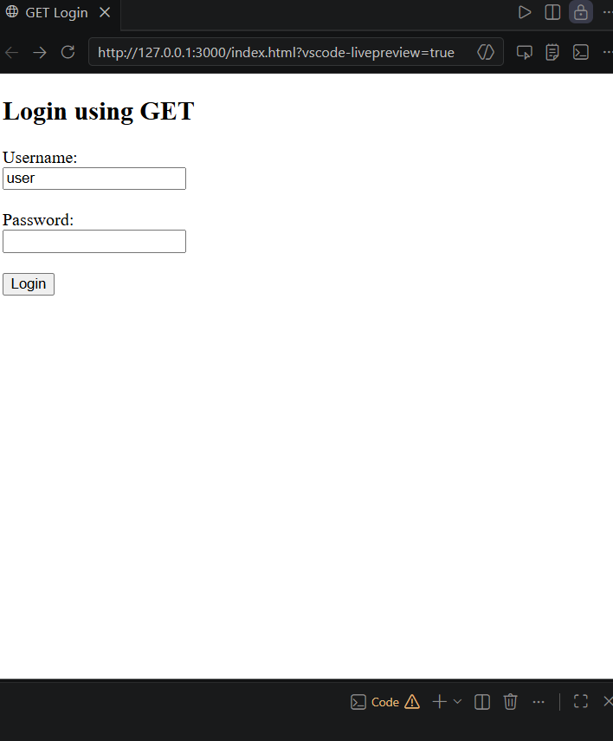
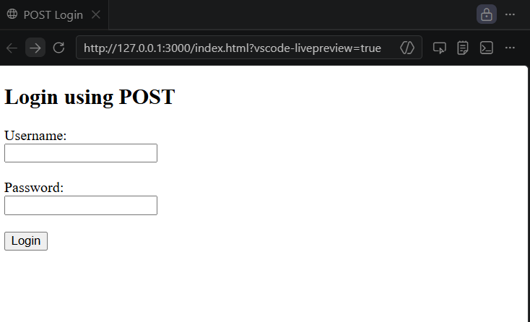

4. HTML Code Inspection
Given Code
<!DOCTYPE html>
<html>
<head>
<title>Sample</title>
</head>
<body>
<h1>Welcome
<p>This is a paragraph
<img src="image.jpg">
</body>
</html>
1. Identify missing closing tags
Missing:
- </h1>
- </p>

2. Analyze issues with the <img> tag
- <img> is a void element and does not require a closing tag.
- However, it is better to include:
<img src="image.jpg" alt="Image">
The alt attribute improves accessibility.

3. Determine how browsers handle these errors
- Browsers automatically close <h1> and <p>.
- Page usually renders correctly.
- Invalid HTML may affect styling and JavaScript behavior.

4. Corrected HTML
<!DOCTYPE html>
<html>
<head>
<title>Sample</title>
</head>
<body>

<h1>Welcome</h1>

<p>This is a paragraph</p>

<img src="image.jpg" alt="Image">

</body>
</html>
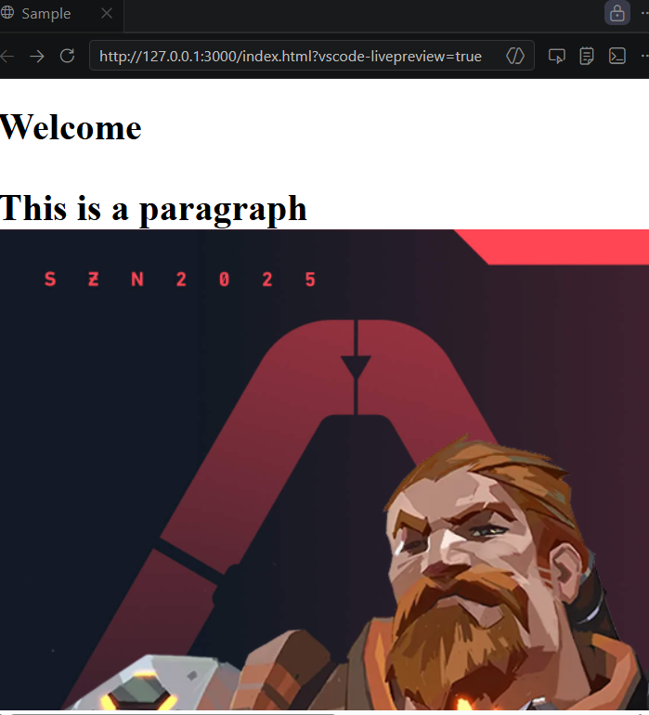

5. Browser–Server Communication Flow
1. Interpret each step
Step | Description
1. User enters URL | Browser receives the website address.
2. DNS lookup | Converts the domain name into an IP address.
3. HTTP request | Browser sends a request to the web server.
4. Server processing | Server processes the request and prepares the response.
5. HTTP response | Server returns HTML, CSS, JavaScript, and other resources.
6. Browser rendering | Browser parses and displays the webpage.

2. Where delays can occur?
- DNS lookup delay.
- Slow network connection.
- Server processing time.
- Large webpage or images.
- Browser rendering of heavy JavaScript.

3. Role of DNS
- Translates a domain name (e.g., example.com) into an IP address.
- Allows the browser to locate the correct web server.
- Without DNS, the browser cannot connect using the domain name.

4. Optimizations to improve performance
- Enable DNS caching.
- Use CDNs (Content Delivery Networks).
- Compress files using Gzip/Brotli.
- Minify HTML, CSS, and JavaScript.
- Optimize images.
- Use browser caching.
- Reduce server response time.
- Enable HTTP/2 or HTTP/3.
